README:

For my personal project I created a platform for the executive board members of the Accounting & Financial Women’s Alliance (AFWA) using a free, online toolkit called Wiggio. This platform will allow everything we need, as board members, to be in one place. It is so simple and easy to use that even our less tech-savvy members will be able to utilize and benefit from it. It provides absolutely everything we need to work productively as a group, and will allow us to connect, collaborate, and engage in new ways. I’m very excited to present Wiggio and all its features at our next board meeting so we can implement it ASAP!

WIGGIO:

I am currently on the executive board of the Accounting & Financial Women’s Alliance (AFWA) and the Institute of Management Accountants (IMA). I have been a member of different executive boards and groups in the past and I’m sure I will continue to participate in them. My experience in these organizations and groups has always been pleasant and positive except for one thing, they are not always the most organized. I have noticed that this is the case whether it’s a professional organization, student organization, large, or small group.

I decided that there must be a more efficient way to keep groups organized and a better way to facilitate communication between the members. After days of researching, I finally found a solution called Wiggio (wiggio.com) that I believe will work.

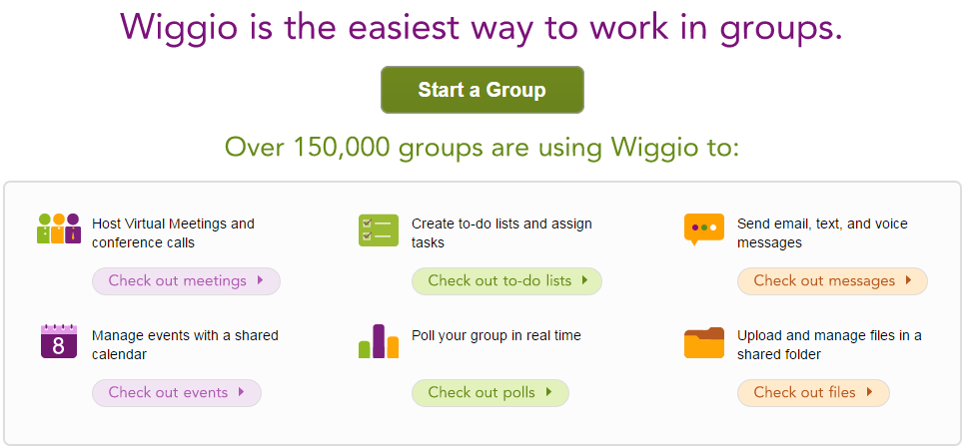

In addition to lack of structure, some of the reoccurring annoyances that I experience being a part of these groups are…

* receiving requests for documents, forms, or contacts that really should be in a location where everyone can access them
* receiving 20 or more emails daily that I am CC’d on, which fill up my inbox and most of the time do not pertain to me
* forgetting to CC people on certain emails, forgetting to Reply All to emails, having someone’s old work email, or having someone on an email chain that is no longer on the board
* not having access to member contact information when it’s needed or having out of date information
* not having an alternative to meeting in person

After exploring and learning about Wiggio, I’m not sure how I ever worked in a group without it! It is an incredible tool for groups and organizations. Some of the helpful features I discovered are…

* The group is protected by password and can be customized with a logo.
* Each member registers with Wiggio, which allows for a central place to keep every ones contact information.

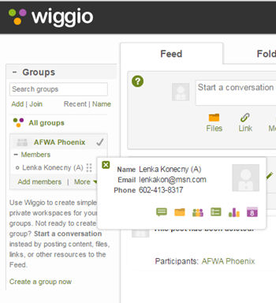

* Members can easily be added or removed so that everyone always has access to the most up to date roster and contact information.
* If a meeting is canceled and it needs to be communicated, then an email or text can be sent to everyone in the group immediately with one click.

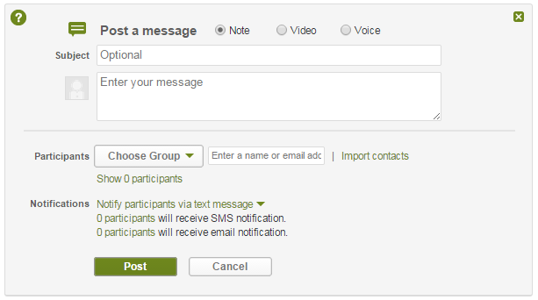

* If you need to contact the group, everyone who is registered with the group receives the message and the replies via a feed on the main page. Each member can set their own personal settings for notifications. You can choose to be notified about every comment posted or you can receive a daily summary of activity at the end of each day.

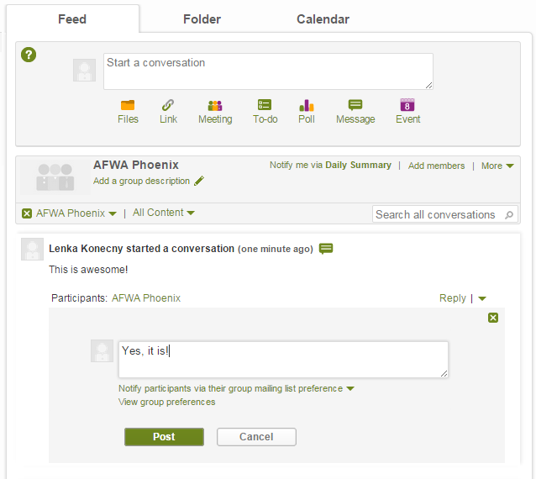

* You may tag members in the feed so they are aware that something is needed from them specifically.
* There is a place to share links and files. They can be uploaded from Google Drive or Dropbox and then everyone in the group can have easy access to meeting minutes, agendas, forms, etc.

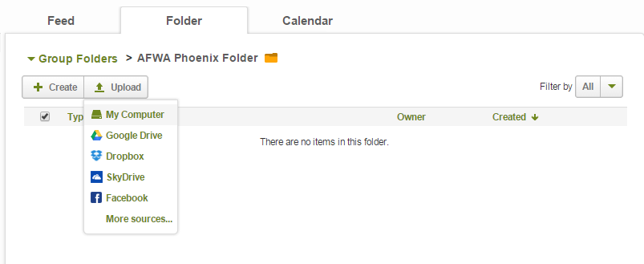

* You can also create files similar to Google Drive. Anytime a document is edited it is tracked by person, date, and time.

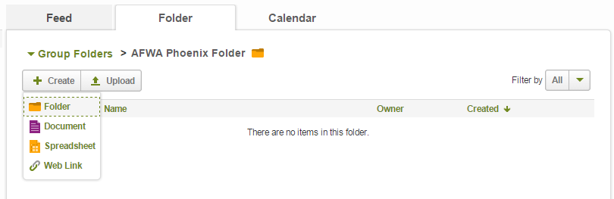

* Wiggio is capable of conference calls, virtual meetings, and chat rooms, which makes meeting regularly more convenient.

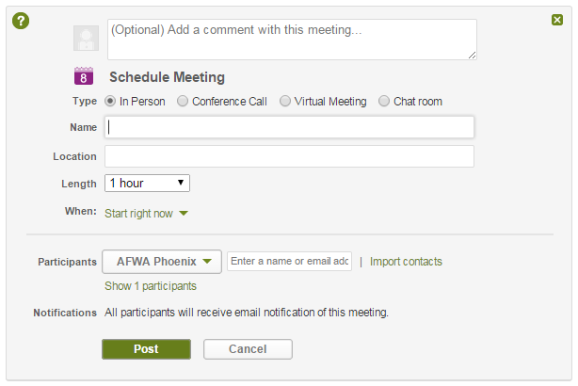

* There is also a shared calendar where all the events for the group can be added. The calendar then sends out reminders based on a member’s preferences. It also has a scheduling tool that helps check everyone’s availability when something needs to be scheduled.

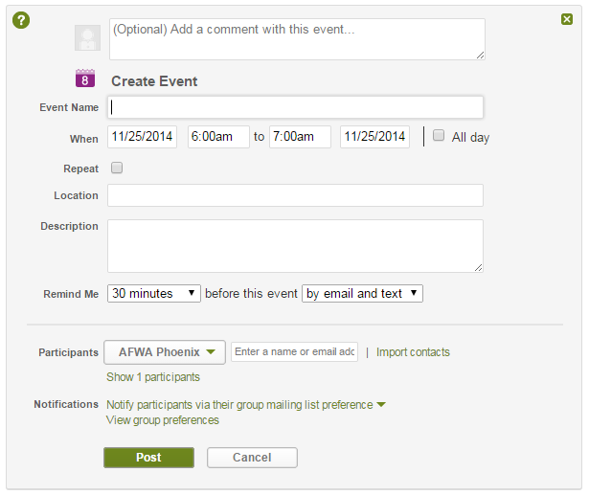

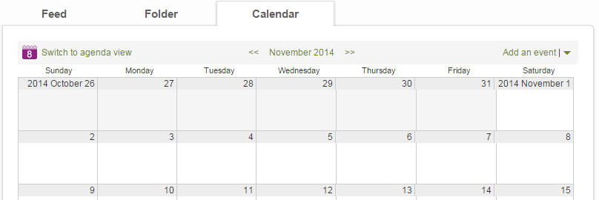

* You can create to-do lists that allow you to assign members and due dates to each task. The list notifies a member of any action item they have coming due and keeps track when something is completed, by whom, and when. Action items with due dates are also populated to the shared calendar to help keep everyone accountable.

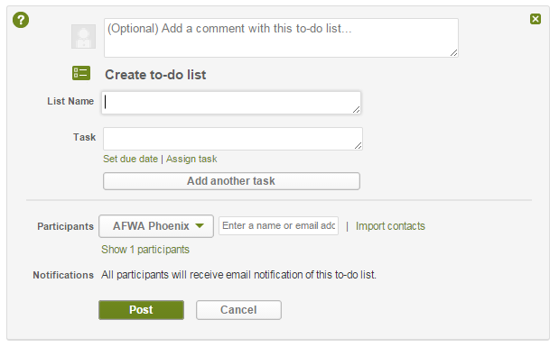

* A voting feature is also available that allows you to send out polls or vote on motions virtually.

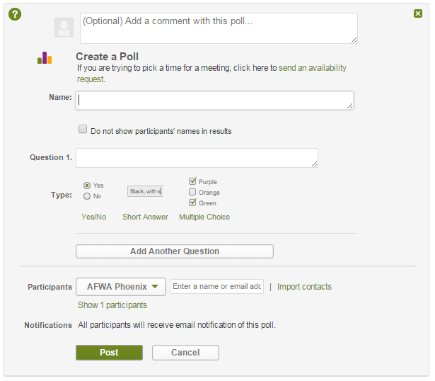

I’m so happy to have found this tool! I think it will be a great asset to the organizations and groups I am part of. I would like to do a little more research and testing before I present Wiggio to the members, but I’m very excited about it and think it will be very beneficial in so many ways!